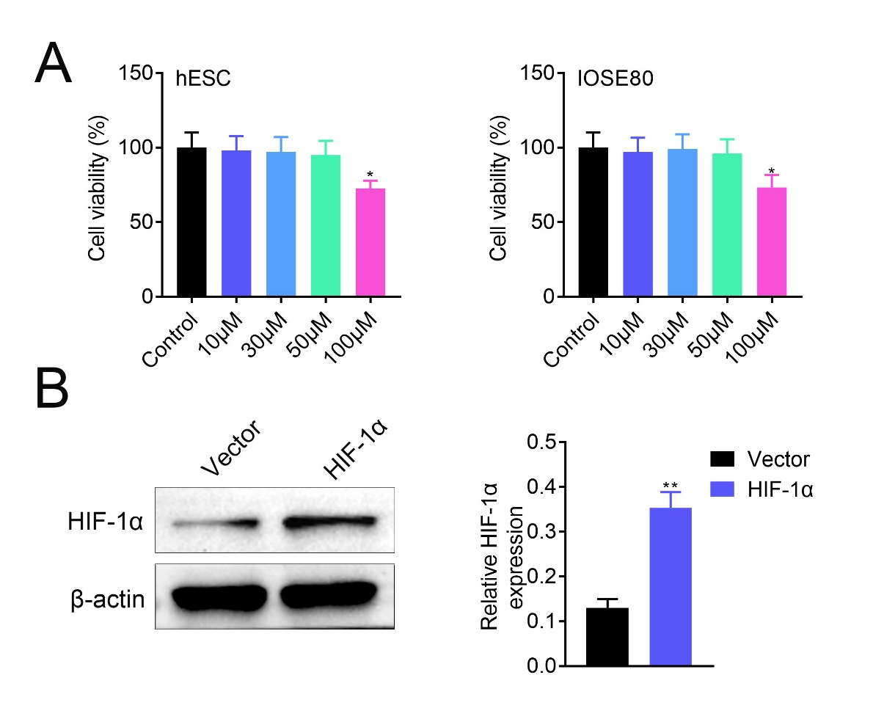
Supplementary Fig. 1. Paeonol 100 μM had no significant effect on the cell viability of normal endometrial stromal cells and IOSE80 cells (A). N = 3. The transfection efficiency of pcDNA-mediated HIF-1α over-expression was detected by western blot (B). N = 3. * p < 0.05. ** p < 0.01.

